CloudTrail SNS CloudWatch
- Enable cloudtrail monitoring and store the events in s3 and cloudwatch log events.

- Create Cloudtrail Monitoring store the events in s3
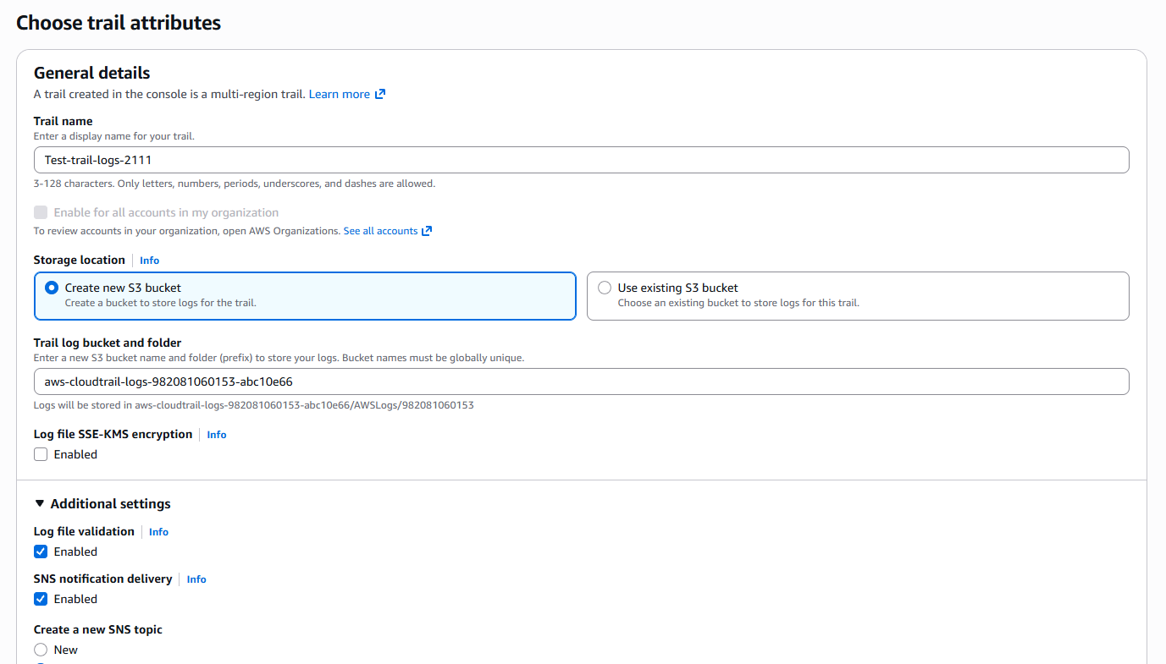

- Enabling CloudWatch Logs events
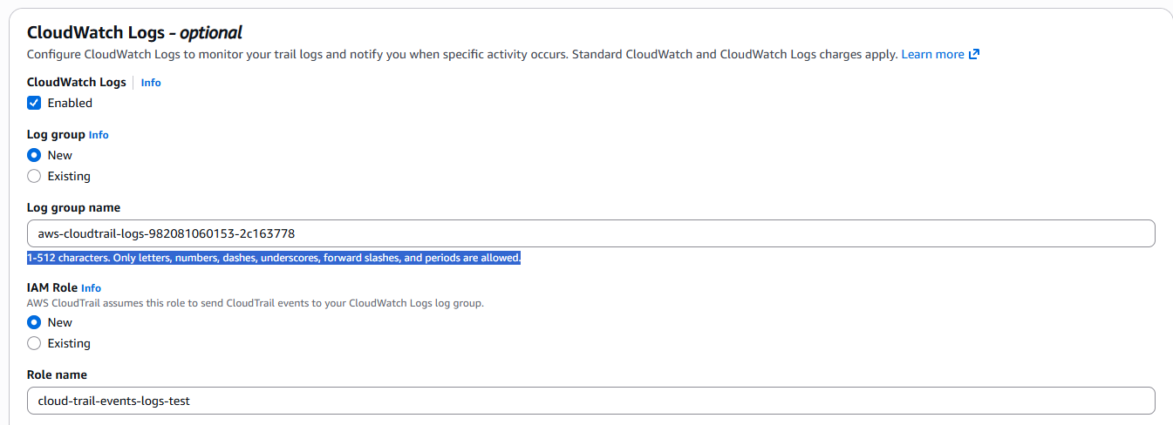
- S3 Bucket Created for CoudTrails Log
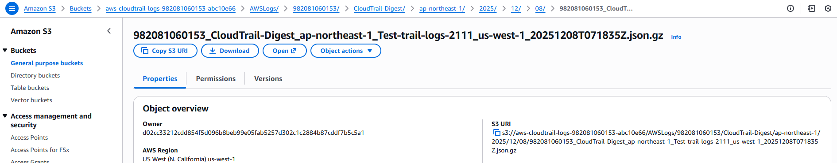

- S3 Bucket Log file data
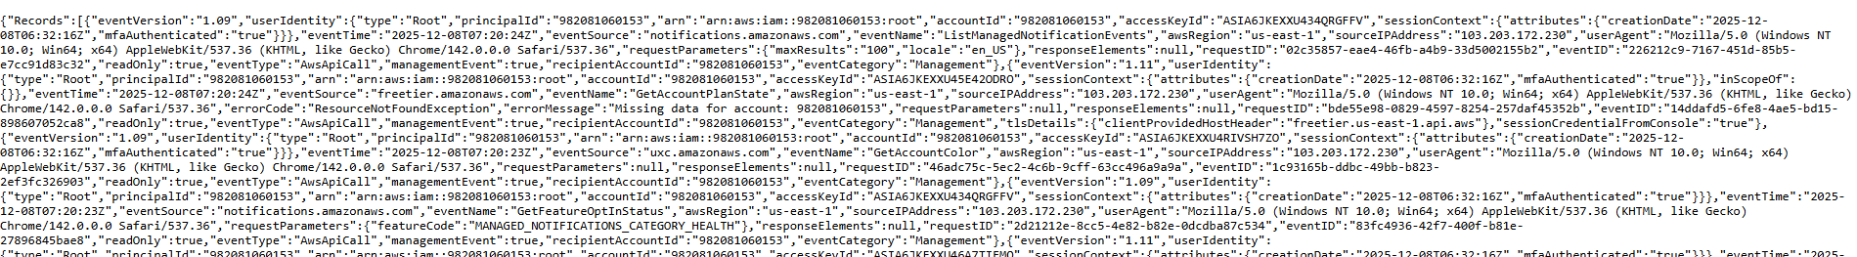

- CloudTrail Created Successfully.
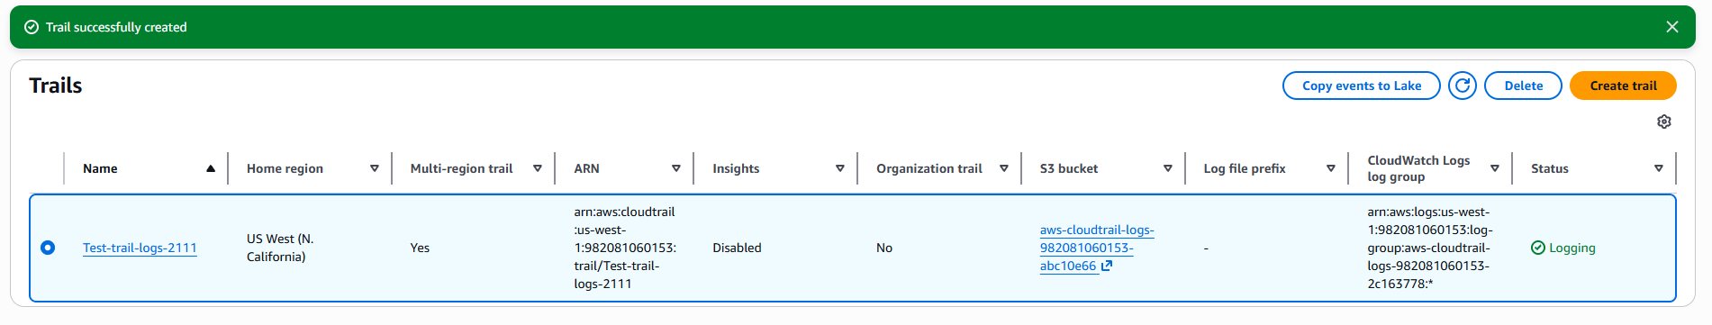

CloudWatch Logs Created
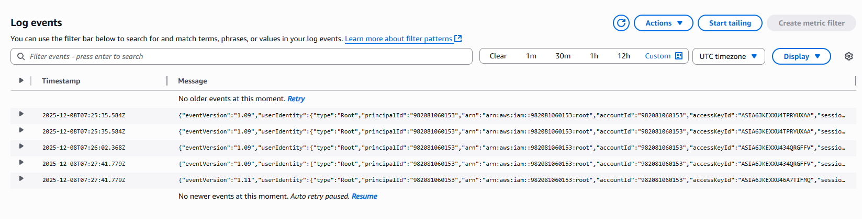
2) Enable SNS for cloudtrial to send alert on email.
- Creating SNS
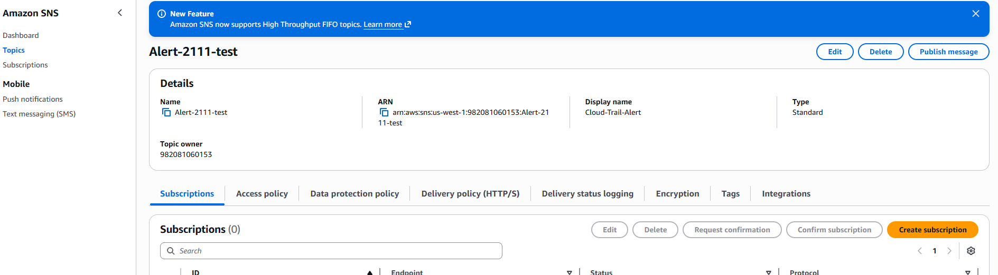
- SNS mail confirmation.
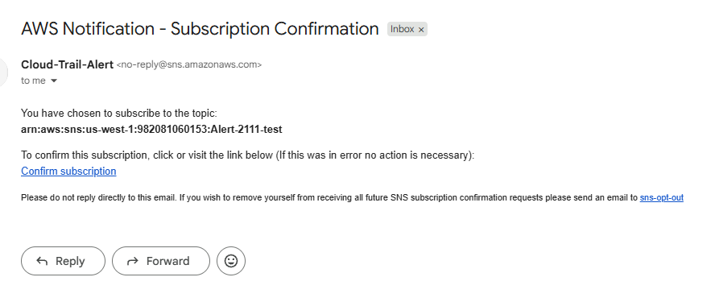
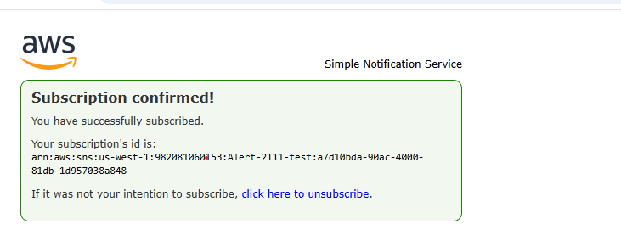
3.Configure cloud watch monitoring and record the cpu utilization and other metrics of ec2.
- Ec2 CloudWatch Monitoring Matrics
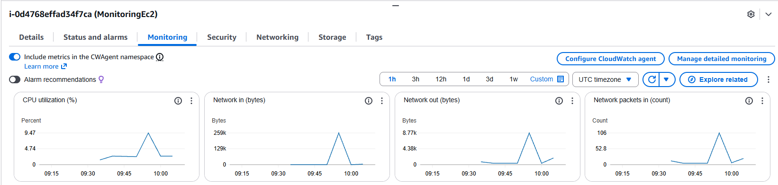
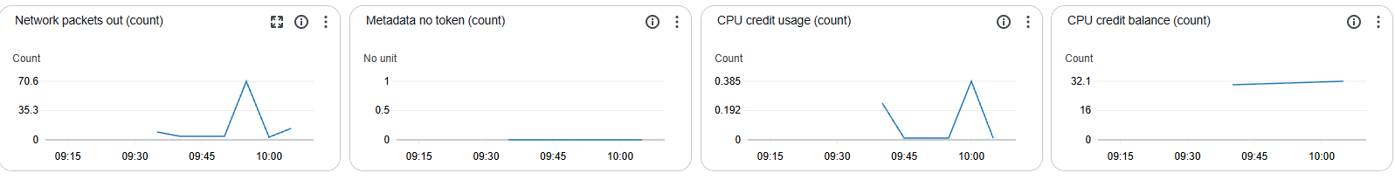

- Ec2 Instance Cpu Utilisation On Metrics:
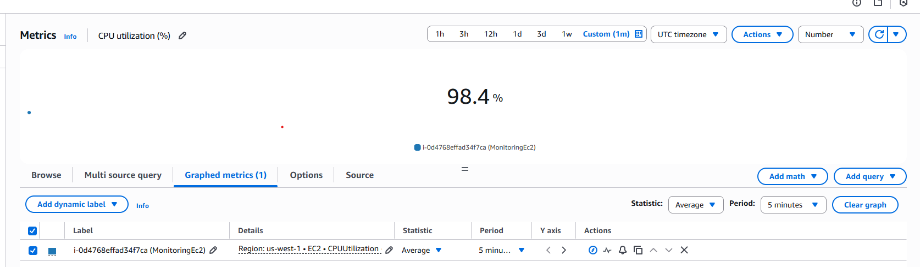

4.Create one alarm to send alert to email if the cpu utilization is more than 70 percent.

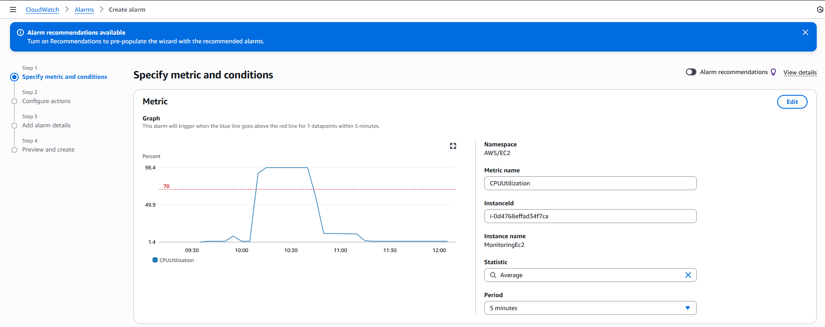
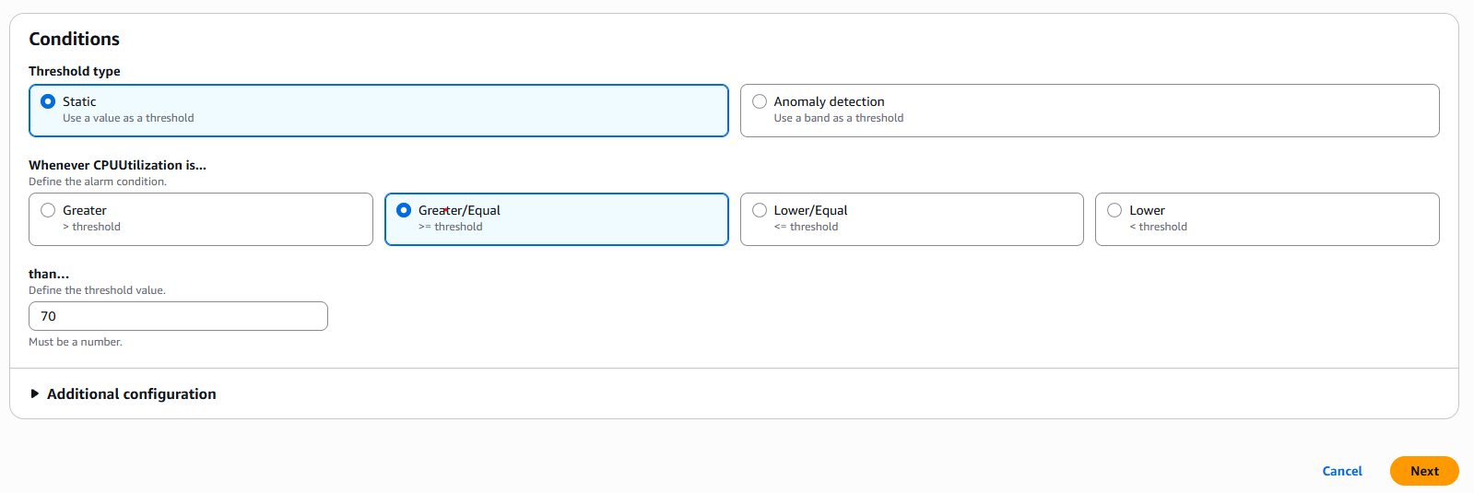
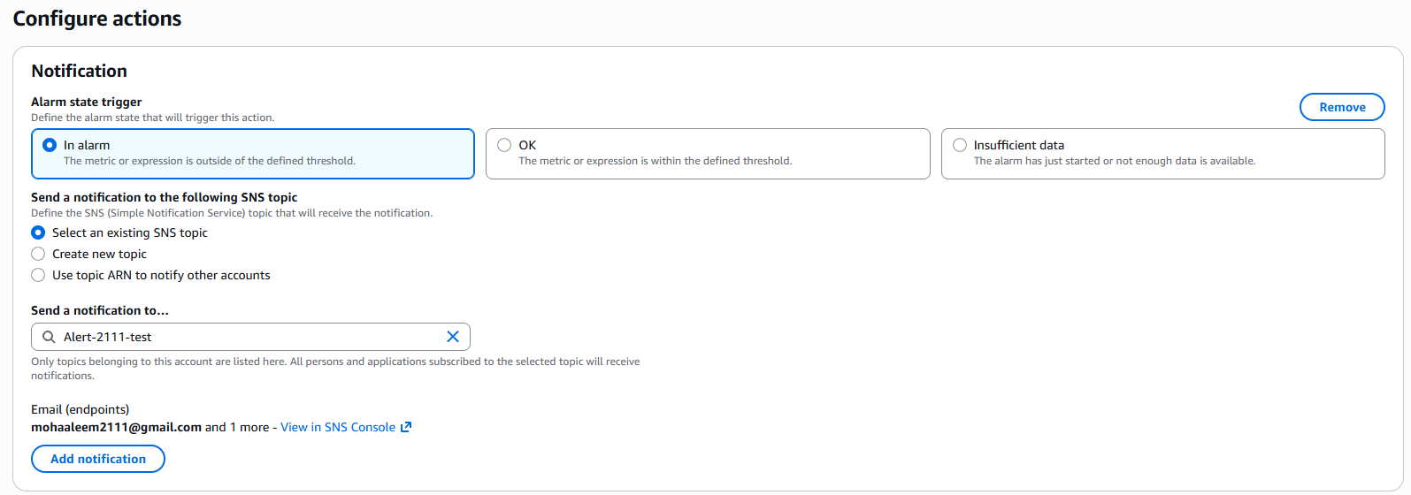
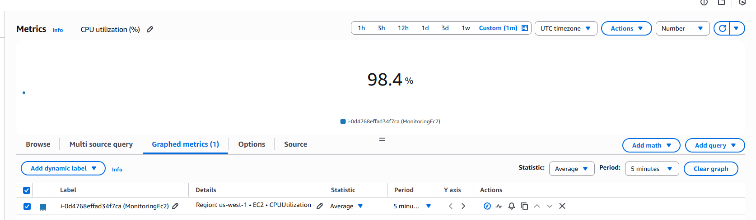
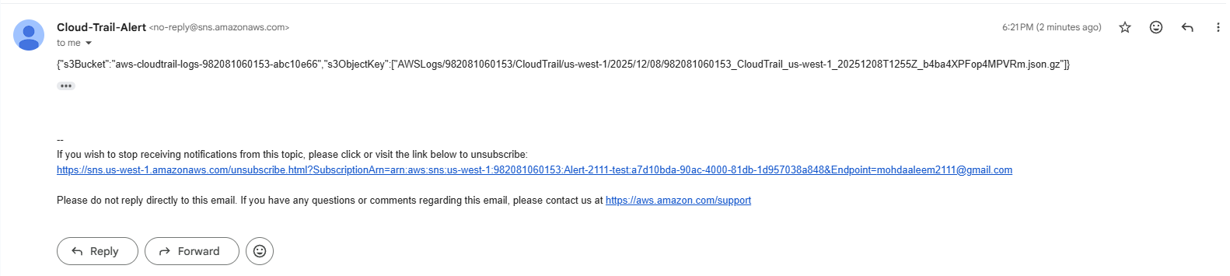

5.Create Dashboard and monitor tomcat service wether it is running or not and send the alert.
1.Create tomcat.bash script to check Tomcat process and push TomcatStatus to CloudWatch.
2.Make the script executable: chmod +x tomcat.bash
3.Test AWS CLI metric manually to confirm it appears in CloudWatch.
4.Add cron job: * * * * * /home/ec2-user/tomcat.bash >> /home/ec2-user/tomcat.log 2>&1.
5.Create CloudWatch alarm (TomcatStatus ≤ 0) and add it to Dashboard.

- Wrote a script for tomcat to check Tomcat monitoring process

- Added tomcat monitoring in crontab using crontab -e

6. Create Dashboard and monitor nginx service to send the alert if nginx is not running.
Steps:
- Create nginx-monitor.sh script to check NGINX service and send NginxStatus to CloudWatch.
- Make it executable: chmod +x nginx-monitor.sh.
- Test sending metric manually using AWS CLI to verify visibility in CloudWatch.
- Add cron job: * * * * * /home/ec2-user/nginx-monitor.sh >> /home/ec2-user/nginx-monitor.log 2>&1.
- Create CloudWatch alarm (NginxStatus ≤ 0) and add widget in Dashboard.

Wrote a script for nginx to check nginx monitoring process

- Nginx script is added in Crontab for monitering nginx working status

- Created dashboard for nginx monitoring

- Added alert in aws console < cloudwatch. The created one alert to monitor nginx working status

